

PROBLEM SOLVING WITH PROGRAMMING

(PSP)

QUIZ GAME

(2021-22)

Developed By:

**K.Sahana Reddy**(2103A54022)

**D.Rahul**(2103A54009)

**N.Shashank Sai**(2103A54032)

**B.Reethika**(2103A51447)

Under the Guidance of

***Dr.P.Praveen Kumar***

Assosiate Professor

Department Computer Science and Artificial Intelligence

***SR University***

Warangal.

**INDEX**

**Sl no. Title Page no.**

**I. Abstract 3**

**II. Introduction 4**

**III. Module Description 5**

**IV. Implementation(code) 5-6-18**

**V. Testing(output) 19-22**

**VI. Conclusion 23**

**I . ABSTRACT**

To devolop a menu drivenprogram using C Language ,we selected “QUIZ GAME”.We can run this code in dev C++ ,code block,visual studio.We can test a person’s knowledge in C Language.

By using this application, we can come to know about how far a person is perfect in C. In this project there are multiple questions, for each for each question there will be given four options. There will be 2 rounds one is warmup round and another one is challenge round. In warmup round you should give at least two right answers to unlock the challenge round .Once you enter the challenge round you will be given 25 questions until you enter round answer.If you enter the wrong answer your game will be finished.And you'll be Shown your score.

**INTRODUCTION**

This project is purely based on C language. Those who want to test their knowledge in C language can play this quiz. If you enter the wrong answer and then the right answer will be displayed on the screen. You can learn many unknown questions from this quiz. This is a perfect application for quizzes. For each right answer you are awarded with 10 points, there is no negative marking for wrong answers. You can also view your high score in this application and also get some help if there are any queries . You can also reset your highscore and also register your name.

**III. MODULE DESCRIPTION**

**Software:** Dev C++ is a free full featured integrated development environment distributed under the general public license for programming in C and C++ . It is written in Delphi.

In this application all variables and structures are declared globally so that these variables and structure members can be accessed throughout the program at any function call. We can choose any function by using function calls which are declared in switch case. In order to repeat the loop control statement (do while) is used with condition. The memory allocation in this program is done dynamically. In this application totally four modules are used

I.READ/INPUT:

In this module the application asks the person who runs the program to enter his or her choice and each choice gives them different options and further continued.

II.PRINT:

In this module all the sorted questions of the quiz will be displayed on the screen. In this module printf function and for loops are used for displaying and repeated displaying.

III.SEARCHING:

In this module there is a sub menu which gives questions only to those who were selected in warmup round and eligible for the challenge round .Searching is used in this module for selecting the desired menu and selecting the right option display correct answer.

**IV.IMPLEMENTATION**

A compilation unit as mandated by the standard and to build a standard confirming C implementation consists of a compiler and executable file.

CODE:

#include<stdio.h>

#include<conio.h>

#include<ctype.h>

#include<stdlib.h>

#include<string.h>

void show_record();

void reset_score();

void help();

void edit_score(float , char []);

int main()

{

int countr,r,r1,count,i,n;

float score;

char choice;

char playername[20];

mainhome:

system("cls");

printf("\t\t\tC PROGRAM QUIZ GAME\n");

printf("\n\t\t________________________________________");

printf("\n\t\t\t WELCOME ");

printf("\n\t\t\t to ");

printf("\n\t\t\t THE GAME ");

printf("\n\t\t________________________________________");

printf("\n\t\t________________________________________");

printf("\n\t\t________________________________________");

printf("\n\t\t > Press S to start the game");

printf("\n\t\t > Press V to view high score ");

printf("\n\t\t > Press R to reset score");

printf("\n\t\t > press H for help ");

printf("\n\t\t > press Q to quit ");

printf("\n\t\t________________________________________\n\n");

choice=toupper(getch());

if (choice=='V')

{

show_record();

goto mainhome;

}

else if (choice=='H')

{

help();getch();

goto mainhome;

}

else if (choice=='R')

{reset_score();

getch();

goto mainhome;}

else if (choice=='Q')

exit(1);

else if(choice=='S')

{

system("cls");

printf("\n\n\n\n\n\n\n\n\n\n\t\t\tResister your name:");

gets(playername);

system("cls");

printf("\n ------------------ Welcome %s to the C Quiz --------------------------",playername);

printf("\n\n Here are some tips you might wanna know before playing:");

printf("\n -------------------------------------------------------------------------");

printf("\n >> There are 2 rounds in this Quiz Game,WARMUP ROUND & CHALLANGE ROUND");

printf("\n >> In warmup round you will be asked a total of 3 questions to test your");

printf("\n C language knowledge. You are eligible to play the game if you give atleast 2");

printf("\n right answers, otherwise you can't proceed further to the Challenge Round.");

printf("\n >> Your game starts with CHALLANGE ROUND. In this round you will be asked a");

printf("\n total of 28 questions.");

printf("\n >> You will be given 4 options and you have to press A, B ,C or D for the");

printf("\n right option.");

printf("\n >> You will be asked questions continuously, untill right answers are given");

printf("\n >> No negative marking for wrong answers!");

printf("\n\n\t!!!!!!!!!!!!! ALL THE BEST !!!!!!!!!!!!!");

printf("\n\n\n Press Y to start the game!\n");

printf("\n Press any other key to return to the main menu!");

if (toupper(getch())=='Y')

{

goto home;

}

else

{

goto mainhome;

system("cls");

}

home:

system("cls");

count=0;

for(i=1;i<=3;i++)

{

system("cls");

r1=i;

switch(r1)

{

case 1:

printf("\n\n What is the size of int?");

printf("\n\nA.2\t\tB.8\n\nC.4\t\tD.NOTA");

if (toupper(getch())=='C')

{

printf("\n\nCorrect!!!");count++;

getch();

break;

}

else

{

printf("\n\nWrong!!! The correct answer is C.4");

getch();

break;

}

case 2:

printf("\n\n\nWho is the father of C Language");

printf("\n\nA.Charles Babbage\t\tB.Alister Cook\n\nC.Dennis Ritchie\t\tD.Bill Gates");

if (toupper(getch())=='C')

{printf("\n\nCorrect!!!");count++;

getch();

break;}

else

{printf("\n\nWrong!!! The correct answer is C.Dennis Ritchie");

getch();

break;}

case 3:

printf("\n\n\nA collection of similar data type elements is called");

printf("\n\nA.Structure\t\tB.Array\n\nC.Pointer\t\tD.Union");

if (toupper(getch())=='B')

{printf("\n\nCorrect!!!");count++;

getch();

break;}

else

{printf("\n\nWrong!!! The correct answer is B.Array");

getch();

break;}

case 4:

printf("\n\n\nThe total number of keywords in C are..");

printf("\n\nA.64\t\tB.32\n\nC.8\t\tD.24");

if (toupper(getch())=='B')

{printf("\n\nCorrect!!!");count++;

getch();

break;}

else

{printf("\n\nWrong!!! The correct answer is B.32");

getch();

break;}

case 5:

printf("\n\n\nWhic of the following is an output function");

printf("\n\nA.scanf()\t\tB.printf()\n\nC.getchar()\t\tD.getch()");

if (toupper(getch())=='B')

{printf("\n\nCorrect!!!");count++;

getch();

break;}

else

{printf("\n\nWrong!!! The correct answer is B.printf()");

getch();

break;}

case 6:

printf("\n\n\nWhich of the following strings is a valid variable name?");

printf("\n\nA.shashank_sher\t\tB.shashank&sher\n\nC.shashank+sher\t\tD.shashank#sher");

if (toupper(getch())=='D' )

{printf("\n\nCorrect!!!");count++;

getch();

break;}

else

{printf("\n\nWrong!!! The correct answer is A.shashank_sher");

getch();

break;}}

}

if(count>=2)

{goto test;}

else

{

system("cls");

printf("\n\nSORRY YOU ARE NOT ELIGIBLE TO PLAY THIS GAME, BETTER LUCK NEXT TIME");

getch();

goto mainhome;

}

test:

system("cls");

printf("\n\n\t*** CONGRATULATION %s you are eligible to play the Game ***",playername);

printf("\n\n\n\n\t!Press any key to Start the Game!");

if(toupper(getch())=='p')

{goto game;}

game:

countr=0;

for(i=1;i<=10;i++)

{system("cls");

r=i;

switch(r)

{

case 1:

printf("\n\nIdentify the loop construct:");

printf("\n\nA.if else\t\tB.goto\n\nC.while\t\tD.switch case");

if (toupper(getch())=='C')

{printf("\n\nCorrect!!!");countr++;getch();

break;getch();}

else

{printf("\n\nWrong!!! The correct answer is C.while");countr++;getch();

goto score;

break;}

case 2:

printf("\n\n\nWhich of the following is not a storage class");

printf("\n\nA.define\t\tB.external\n\nC.automatic\t\tD.register");

if (toupper(getch())=='A')

{printf("\n\nCorrect!!!");countr++;getch();

break;}

else

{printf("\n\nWrong!!! The correct answer is A.define");getch();

goto score;

break;

}

case 3:

printf("\n\n\nHow many while statements are possible in do.... While loop? ");

printf("\n\nA.0\t\tB.4\n\nC.infinite\t\tD.1");

if (toupper(getch())=='C')

{printf("\n\nCorrect!!!");countr++;getch();

break;}

else

{printf("\n\nWrong!!! The correct answer is C.infinite");getch();

goto score;

break;}

case 4:

printf("\n\n\nThe global variable can be declared?");

printf("\n\nA.Before main\t\tB.After main\n\nC.After block\t\tD.Within Block");

if (toupper(getch())=='A')

{printf("\n\nCorrect!!!");countr++;getch();

break;}

else

{

printf("\n\nWrong!!! The correct answer is A.Before main");getch();

goto score;

break;

}

case 5:

printf("\n\n\nAll the elements in the array must be");

printf("\n\nA.Initialized\t\tB.Defined\n\nC.Processed\t\tD.Called");

if (toupper(getch())=='B')

{printf("\n\nCorrect!!!");countr++;getch(); break;}

else

{

printf("\n\nWrong!!! The correct answer is B.Defined");

getch();

goto score;

break;

}

case 6:

printf("\n\n\nIf statement is a__________ statement");

printf("\n\nA.Loop construct\t\tB.Two way decision\n\nC.Multy way decision\t\tD.One way decision");

if (toupper(getch())=='B' )

{printf("\n\nCorrect!!!");countr++;getch();

break;}

else

{printf("\n\nWrong!!! The correct answer is B.Two way decision");goto score;

getch();

break;}

case 7:

printf("\n\n\nNumber of keywords present in C language are");

printf("\n\nA.34\t\tB.64\n\nC.62\t\tD.32");

if (toupper(getch())=='D')

{printf("\n\nCorrect!!!");countr++;getch();

break;}

else

{printf("\n\nWrong!!! The correct answer is D.32");getch();

goto score;

break;}

case 8:

printf("\n\n\nA C program is a combination of?");

printf("\n\nA.Statements\t\tB.Functions\n\nC.Variables\t\t D.All of the above");

if (toupper(getch())=='D')

{printf("\n\nCorrect!!!");countr++;getch(); break;}

else

{printf("\n\nWrong!!! The correct answer is D.All of the above");getch();

goto score;

break;}

case 9:

printf("\n\n\nC language is used in devolopment of______.");

printf("\n\nA.Data bases\t\tB.Word processors\n\nC.Graphic applications\t\tD.All of the above");

if (toupper(getch())=='D')

{printf("\n\nCorrect!!!");countr++; getch();

break;}

else

{printf("\n\nWrong!!! The correct answer is D.All of the above");

getch();

goto score;

break;}

case 10:

printf("\n\n\nWhich of the following is not a correct variable type....");

printf("\n\nA.Real\t\tB.float\n\nC.int\t\tD.char");

if (toupper(getch())=='A')

{printf("\n\nCorrect!!!");countr++;getch(); break;}

else

{printf("\n\nWrong!!! The correct answer is A.Real");getch();break;goto score;}

case 11:

printf("\n\n\nWhich is the only function all C programs must contain?");

printf("\n\nA.printf()\t\tB.scanf()\n\nC.main()\t\tD.getch()");

if (toupper(getch())=='C')

{printf("\n\nCorrect!!!");countr++;getch();

break;}

else

{printf("\n\nWrong!!! The correct answer is C.main()");getch();

break;goto score;}

case 12:

printf("\n\n\nA c variable cannot start with");

printf("\n\nA.A number\t\tB.A special symbol(excluding underscore)\n\nC.Both of the above\t\tD.An alphabet");

if (toupper(getch())=='C')

{printf("\n\nCorrect!!!");countr++;getch();

break;}

else

{printf("\n\nWrong!!! The correct answer is C.Both of the above");getch();

break;goto score;}

case 13:

printf("\n\n\nEach statement in C program should end with");

printf("\n\nA.colon\t\tB.comma\n\nC.closed bracket\t\tD.semi colon");

if (toupper(getch())=='D')

{printf("\n\nCorrect!!!");countr++;getch();

break;}

else

{printf("\n\nWrong!!! The correct answer is D.semi colon");getch();

break;goto score;}

case 14:

printf("\n\n\nC was primarily devoloped as");

printf("\n\nA.System programming language\t\tB.General purpose language\n\nC.Data processing languaget\tD.NOTA");

if (toupper(getch())=='A')

{printf("\n\nCorrect!!!");countr++;getch();

break;}

else

{printf("\n\nWrong!!! The correct answer is A.System programming language");getch();

break;goto score;}

case 15:

printf("\n\n\nWhat is a character file output function");

printf("\n\nA.fseek\t\tB.fputc\n\nC.fprintf\t\tD.fgetc");

if (toupper(getch())=='B')

{printf("\n\nCorrect!!!");countr++;getch();

break;}

else

{printf("\n\nWrong!!! The correct answer is B.fputc");getch();

goto score;

break;}

case 16:

printf("\n\n\nWhat is a character file input function ");

printf("\n\nA.fseek\t\tB.fputc\n\nC.fprintf\t\tD.fgetc");

if (toupper(getch())=='D')

{printf("\n\nCorrect!!!");countr++; getch();

break;

}

else

{printf("\n\nWrong!!! The correct answer is D.fgetc");getch();

goto score;

break;}

case 17:

printf("\n\n\nWhat will be return if fopen() fails to open a file");

printf("\n\nA.Null\t\tB.0\n\nC.Garbage value\t\tD.1");

if (toupper(getch())=='A')

{printf("\n\nCorrect!!!");countr++; getch();

break;}

else

{printf("\n\nWrong!!! The correct answer is A.Null");getch();goto score;

break;}

case 18:

printf("\n\n\nWhat is the size of long double variabe");

printf("\n\nA.4\t\tB.8\n\nC.1\t\tD.10\n\n");

if (toupper(getch())=='D')

{printf("\n\nCorrect!!!");countr++; getch();

break;}

else

{printf("\n\nWrong!!! The correct answer is D.10");getch();goto score;

break;}

case 19:

printf("\n\n\nWhat is the extension of C source program");

printf("\n\nA..C\tB..obj\n\nC..exp\tD..cp\n\n");

if (toupper(getch())=='A')

{printf("\n\nCorrect!!!");countr++; getch();

break;}

else

{printf("\n\nWrong!!! The correct answer is A..C");getch();goto score;

break;}

case 20:

printf("\n\n\nThe number of loop constructs in C");

printf("\n\nA.1\t\tB.3\n\nC.4\t\tD.2");

if (toupper(getch())=='B')

{printf("\n\nCorrect!!!");countr++; getch();

break;}

else

{printf("\n\nWrong!!! The correct answer is B.3");getch();goto score;

break;}

case 21:

printf("\n\n\nThe function pow() is a part of header file");

printf("\n\nA.windows.h\t\tB.stdlib.h\n\nC.string.h\t\tD.math.h");

if (toupper(getch())=='D')

{printf("\n\nCorrect!!!");countr++; getch();

break;}

else

{printf("\n\nWrong!!! The correct answer is D.math.h");getch();goto score;

break;}

case 22:

printf("\n\n\n What is unconditional control statement");

printf("\n\nA.switch\t\tB.while\n\nC.if else\t\tD.goto");

if (toupper(getch())=='D')

{printf("\n\nCorrect!!!");countr++; getch();

break;}

else

{printf("\n\nWrong!!! The correct answer is D.goto");getch();goto score;

break;}

case 23:

printf("\n\n\n_________ is a mechanism to convert one data type to another");

printf("\n\nA.recurssion\t\tB.macro substitution\n\nC.Type casting\t\tD.NOTA");

if (toupper(getch())=='C')

{

printf("\n\nCorrect!!!");countr++; getch();

break;}

else

{printf("\n\nWrong!!! The correct answer is C.Type casting");getch();goto score;

break;}}}

score:

system("cls");

score=(float)countr*10;

if(score>0.00 && score<100)

{

printf("\n\n\t\t**************** CONGRATULATIONS *****************");

printf("\n\t Your Score is %.2f",score);goto go;}

else if(score>=100.00)

{

printf("\n\n\n \t\t**************** CONGRATULATIONS ****************");

printf("\n\t\t\t\t YOU HAVE GOOD COMMAND ON C-LANGUAGE!!!!!!!!!");

printf("\n\t\t Your Score is %.2f",score);

printf("\t\t Thank You!!");

}

else

{

printf("\n\n\t******** SORRY YOU DIDN'T GET FULL MARKS********");

printf("\n\t\t Thanks for your participation");

printf("\n\t\t TRY AGAIN");goto go;}

go:

puts("\n\n Press Y if you want to play next game");

puts(" Press any key if you want to go main menu");

if (toupper(getch())=='Y')

goto home;

else

{

edit_score(score,playername);

goto mainhome;}}}

void show_record()

{system("cls");

char name[20];

float scr;

FILE *f;

f=fopen("score.txt","r");

fscanf(f,"%s%f",&name,&scr);

printf("\n\n\t\t*************************************************************");

printf("\n\n\t\t %s has secured the Highest Score %0.2f",name,scr);

printf("\n\n\t\t*************************************************************");

fclose(f);

getch();}

void reset_score()

{system("cls");

float sc;

char nm[20];

FILE *f;

f=fopen("score.txt","r+");

fscanf(f,"%s%f",&nm,&sc);

sc=0;

fprintf(f,"%s,%.2f",nm,sc);

fclose(f);}

void help()

{system("cls");

printf("\n\n HELP");

printf("\n -------------------------------------------------------------------------");

printf("\n ......................... C program Quiz Game...........");

printf("\n >> There are two rounds in the game, WARMUP ROUND & CHALLANGE ROUND");

printf("\n >> In warmup round you will be asked a total of 3 questions to test your general");

printf("\n knowledge. You will be eligible to play the game if you can give atleast 2");

printf("\n right answers otherwise you can't play the Game...........");

printf("\n >> Your game starts with the CHALLANGE ROUND. In this round you will be asked");

printf("\n total 28 questions .");

printf("\n >> You will be given 4 options and you have to press A, B ,C or D for the");

printf("\n right option");

printf("\n >> You will be asked questions continuously if you keep giving the right answers.");

printf("\n >> No negative marking for wrong answers");

printf("\n\n\t*********************BEST OF LUCK*********************************");}

void edit_score(float score, char plnm[20])

{

system("cls");

float sc;

char nm[20];

FILE *f;

f=fopen("score.txt","r");

fscanf(f,"%s%f",&nm,&sc);

if (score>=sc)

{ sc=score;

fclose(f);

f=fopen("score.txt","w");

fprintf(f,"%s\n%.2f",plnm,sc);

fclose(f);}}

OUTPUT:

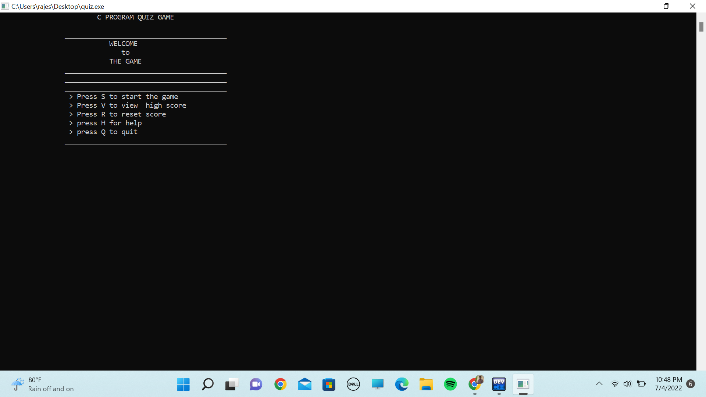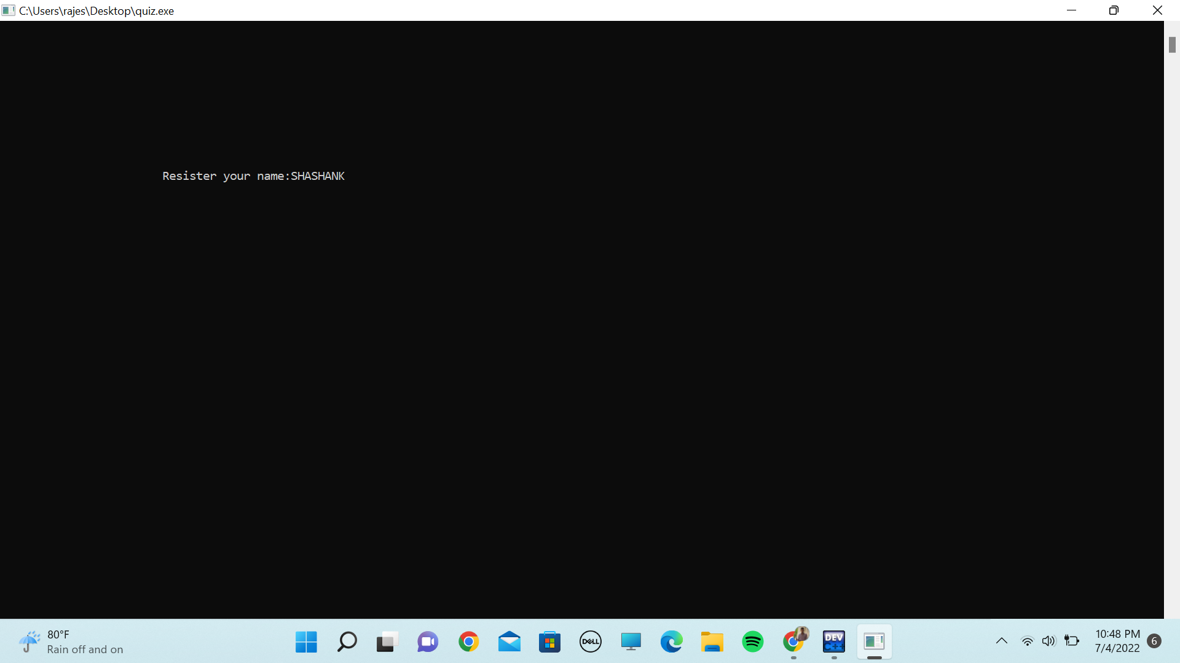

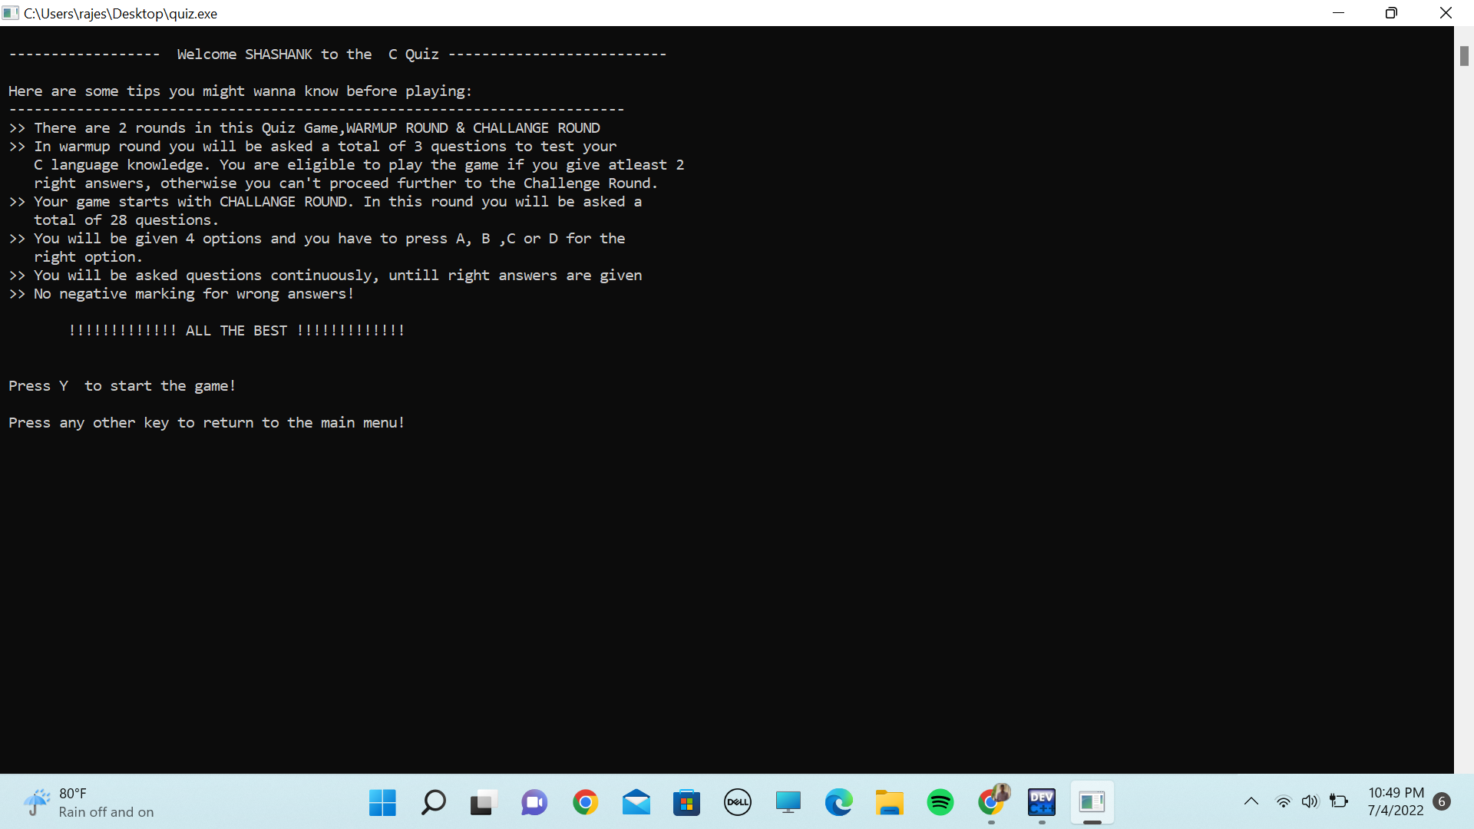

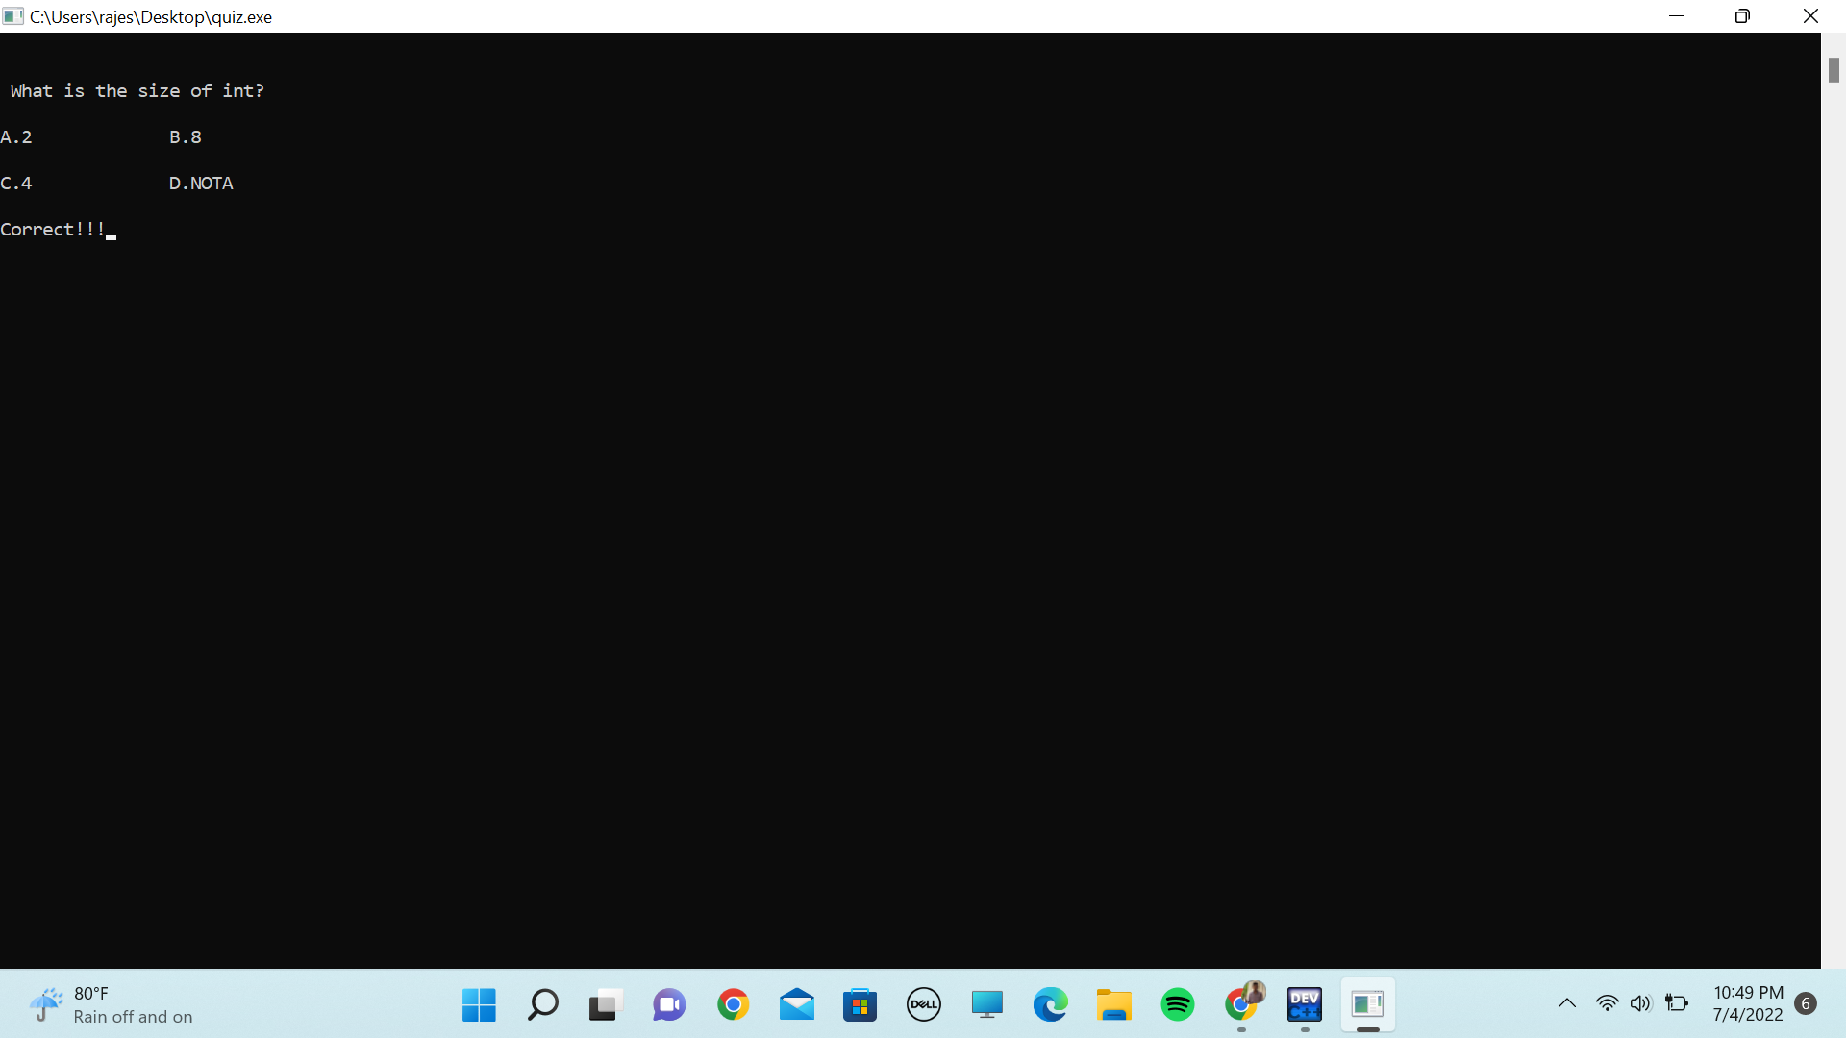

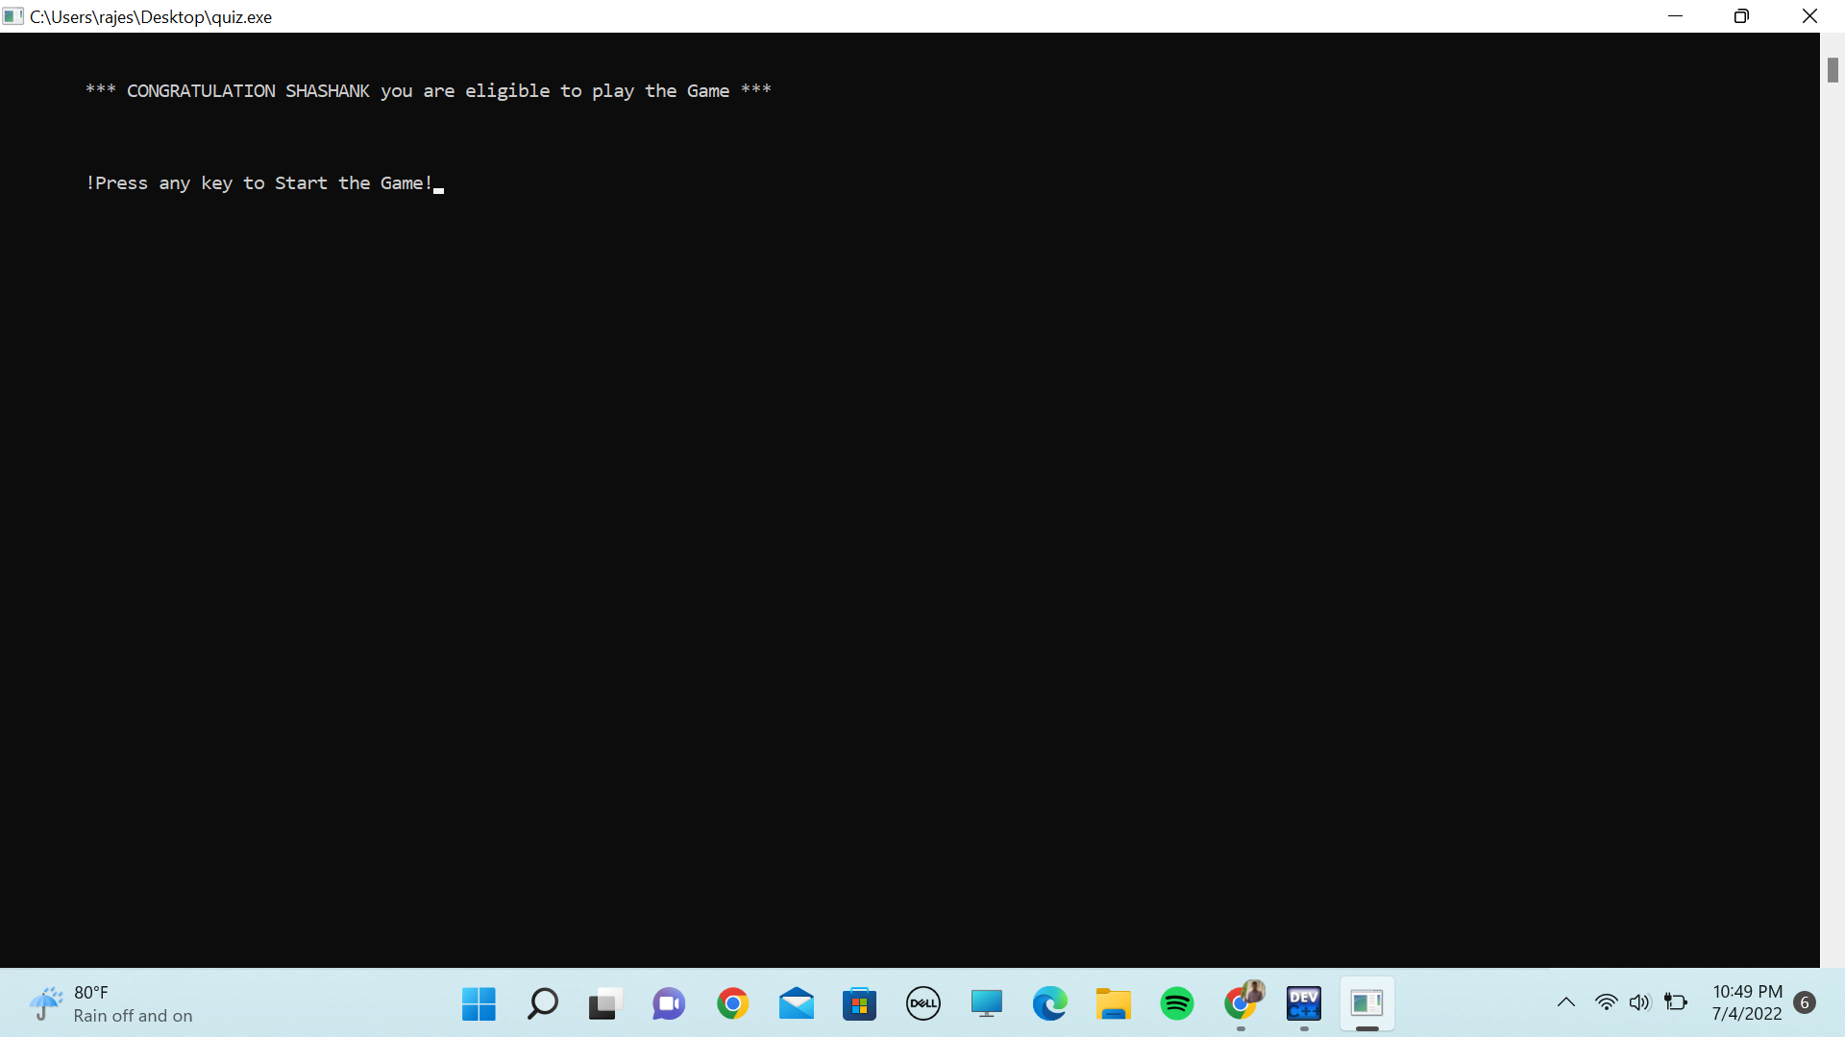

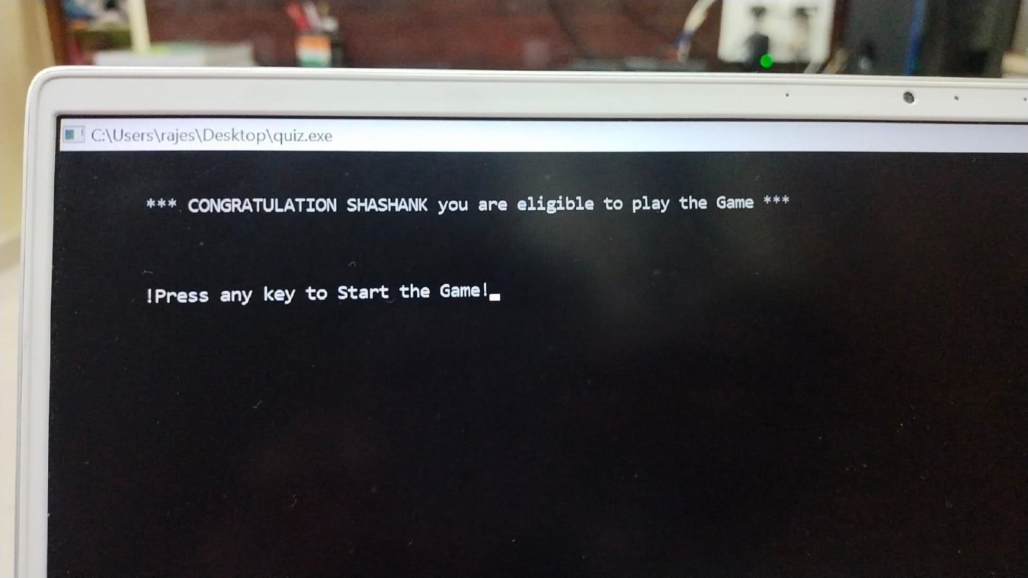

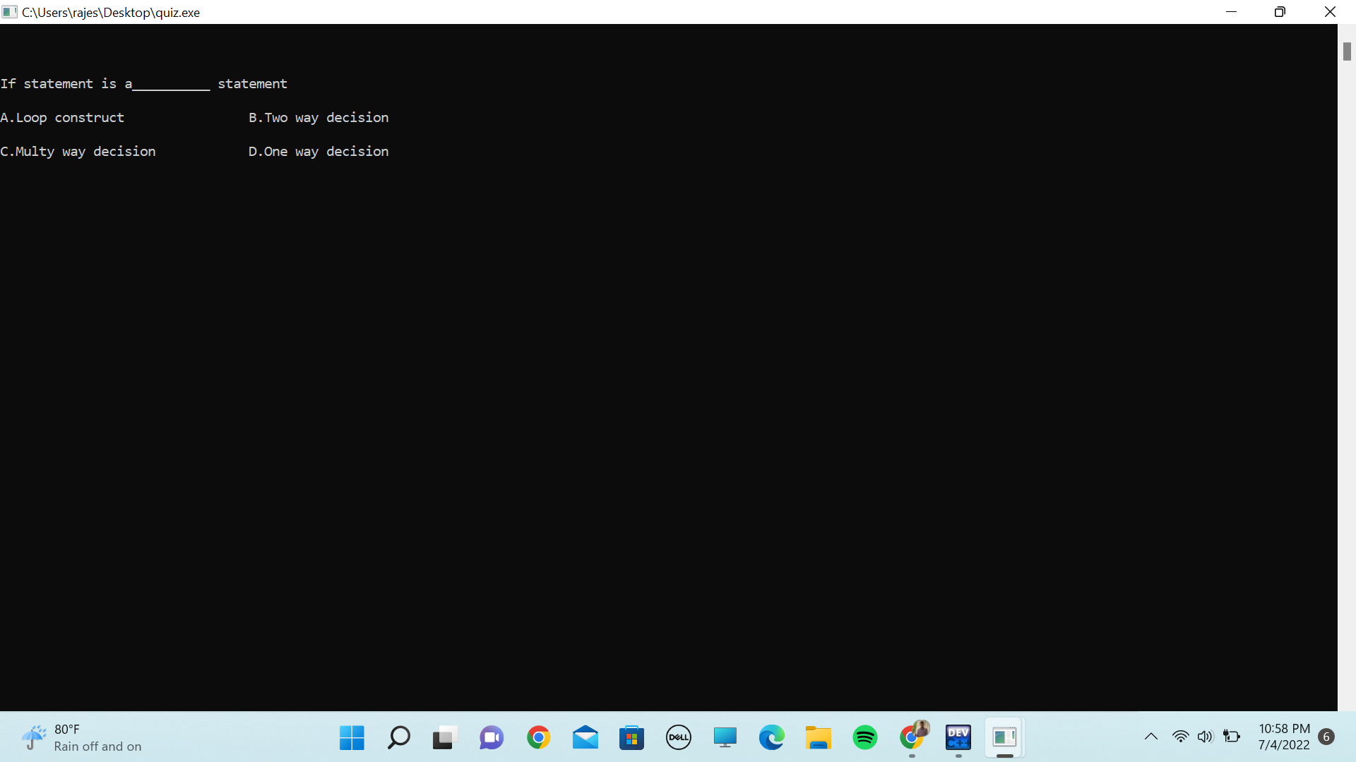

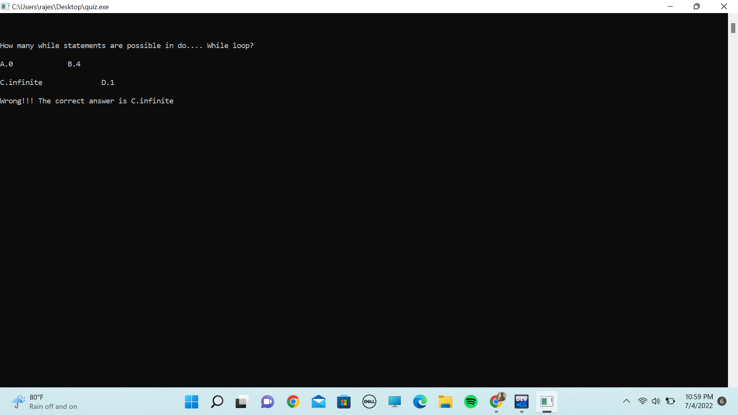

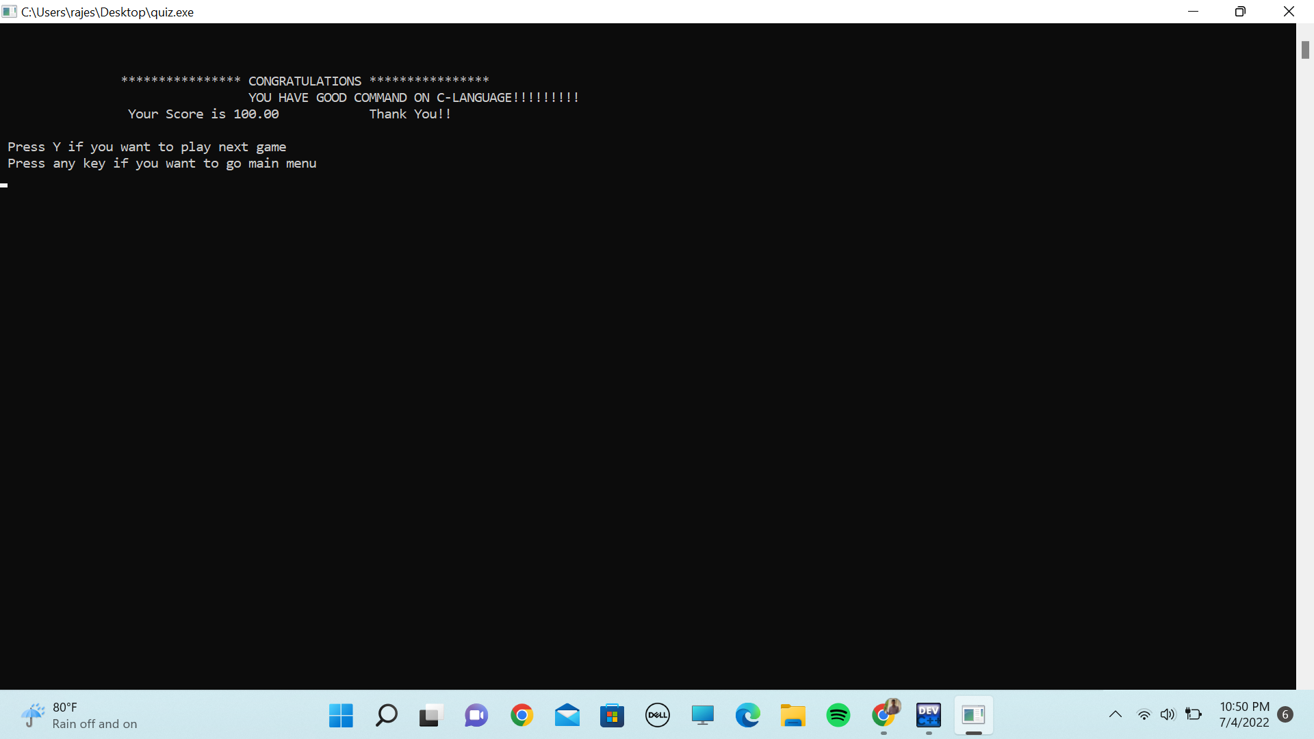

CONCLUSION

The project entitled C program quiz is very useful for students to increase and yesterday their knowledge in C. The main objective of C program quiz is to improve the students knowledge and to test them. It can be able to give your daily wise performance And can correct you with proper answers when your answer is wrong and can be used easily than online quiz links.